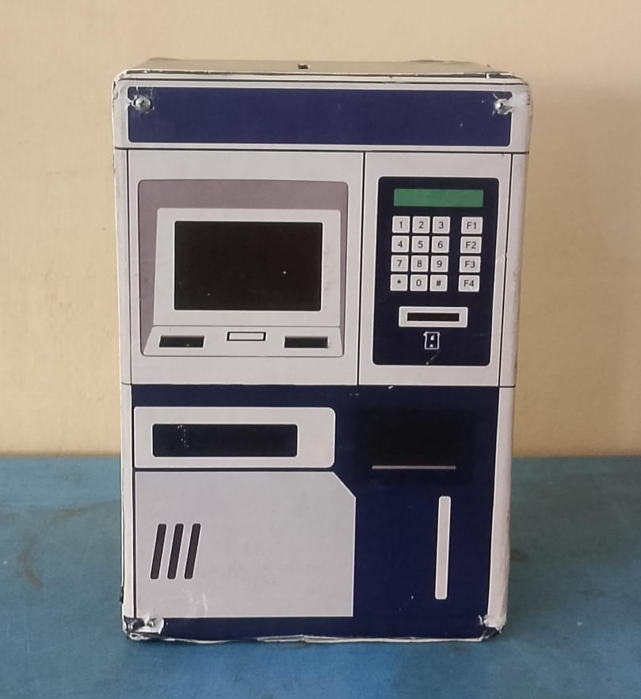

Link Drive Foto Produk:
https://drive.google.com/drive/folders/1pFbb1OCZhqVbx-1m16pOl4-8JwV_umlm?usp=drive_link

